**Value Momentum Corporation**

**Policy Systems**

Value addons

PROPOSAL DOCUMENT

Presented by: Gopi Raj Anupa

Contents-

1. **Endorsemnt Tool Integration With Policy Systems**
2. **Use Selenium Web Driver To Create Submisions For Unit Test**
3. **Policy System Submission Flags(Draft, Invalid, Invalid Rater Imported, Fraud Detection)**
4. **Modern Python Libraries To Test Two Pdf Files(Graphical And Content)**
5. **Dash Board Graphical Filters Using Drop Down To Make UI Interactive**

# Endorsement Integration with Policy Systems InSights:

Endorsement exe tool is to integrate with policy systems in a tab to organize and auto generate the alignment changes.

## nO mANUAL iNTERUPTION

No Manual intervention need for endorsements script preparation for adding alignments and bold tags.

## Reduce time & effort

Automation of endorsement document makes easier to prepare for scripts.

**Requirements:**

Microsoft office Interop word

## WORK FLOW:

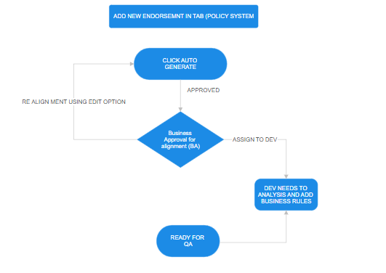

Above flow chart explains the work flow after Integration Process.

# Use of Selenium web driver extensions for submissions:

## Corns:

To create risks or use exiting required risk might be time consuming process at the stage of development.

## Prons:

Using selenium chrome extension methods, we can record once and play the steps of the application and save those steps in JSON format in a folder.

STEPS TO USE :(RECORD & PLAY)

Create few records (one time) and execute the JSON file with the help of chrome extension thus invokes the browser with given local host URL and auto selects the data which saved in JSON file.

Each developer can one time create a single program and share the output project file in between team,

Whenever the unit test is need, instead creating on one we can simply click those files and that performs faster as required.

Requirement:

Selenium IDE (CHROME /EDGE EXTENSIONS) Open Source.

**HOW TO ADD?**

**Chrome -> Extension->manage Extensions->SEARCH FOR selenium ide.**

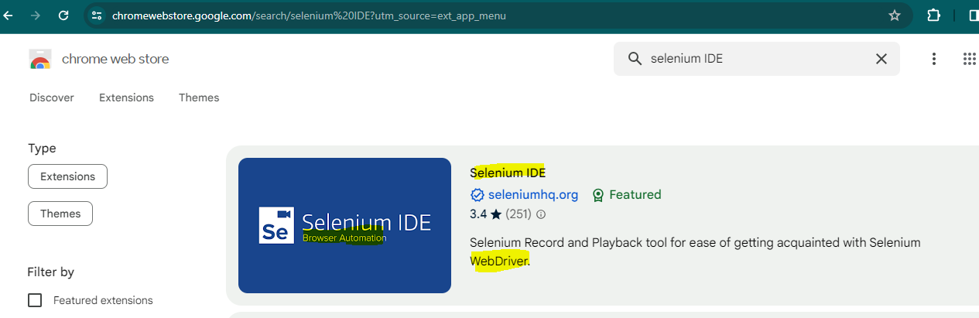

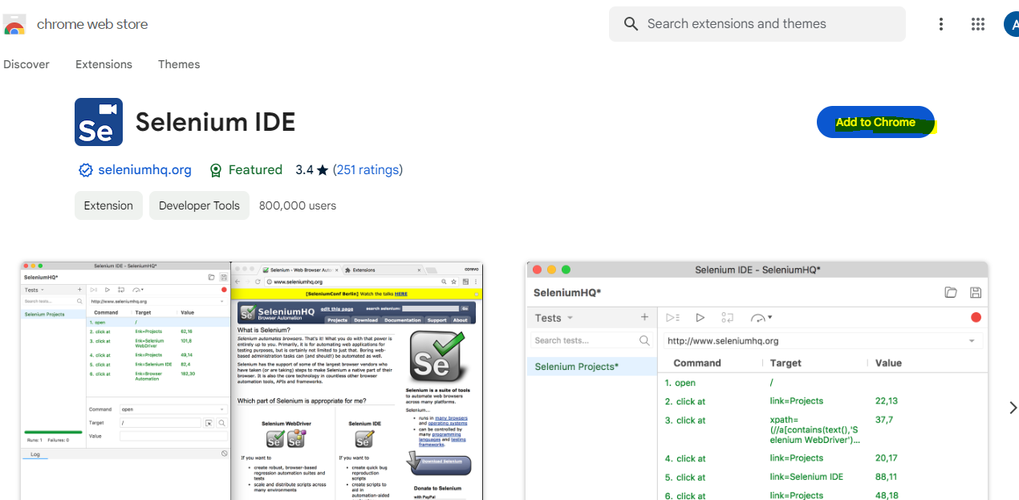

**Add to Chrome**

**How to USE?**

1. Once chrome extensions are added we can find it in extensions section in browser.
2. Click extensions and create a new project
3. Click create a new project (create for each program)
4. 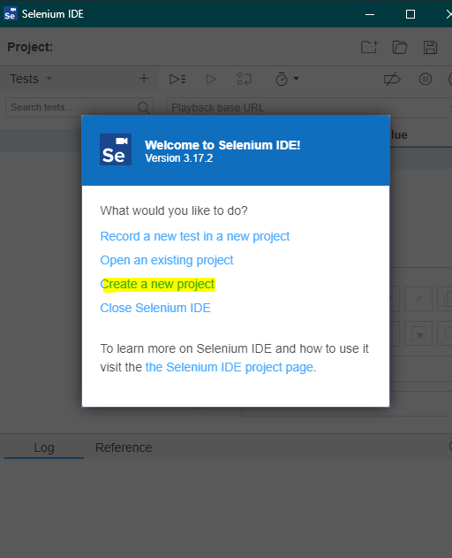
5. Record each steps and play the steps using selenium web driver.

# Policy system Flags on Submission:

Flags is a new feature that I would like to propose for the policy system to make a submission flag it on below or any other criteria, basically a flag defines the submission as a bookmark to revisit the submission from the pocket of an under writer, flagged submissions can only be viewed by respective created under writers or authorized persons

Flag Can be applied to submission in below one are other criteria:

1. Bookmark to review later incomplete submissions (Currently last visited tab will be redirected in PS, UW needs to search for risks he created)
2. Flag the submission says its having wrong rater values
3. Fraud detections on policy level (from insured or any other prospective)
4. Risk factor (high, low, medium)
5. **Can also implement Risk Analysis on previous claims by insured, premiums made thus give a factor.**

# Use python library to compare two pdf files:(Required:R&D)

Corns: for both tester and developer need manual intervention to compare each word with source document even a fill-in change.

**Content Wise:**

By using python libraries like **pdfplumber** library that extract the content in source and output document then validate the both files.

**Graphical Wise:**

By using python libraries like **PyMuPDF** library renders the pdf as images and compare pixel by pixel with source document and identify the visually.

**Requirements:**

PYTHON LIBRARY **PyMuPDF**, **pdfplumber**

# Dash Board UI CHANGES:

Search GUI filters needed to make easy go for an application use.

Search can be made drop downs to filter program wise, cost center, premium range, bound, status as its existing with code.